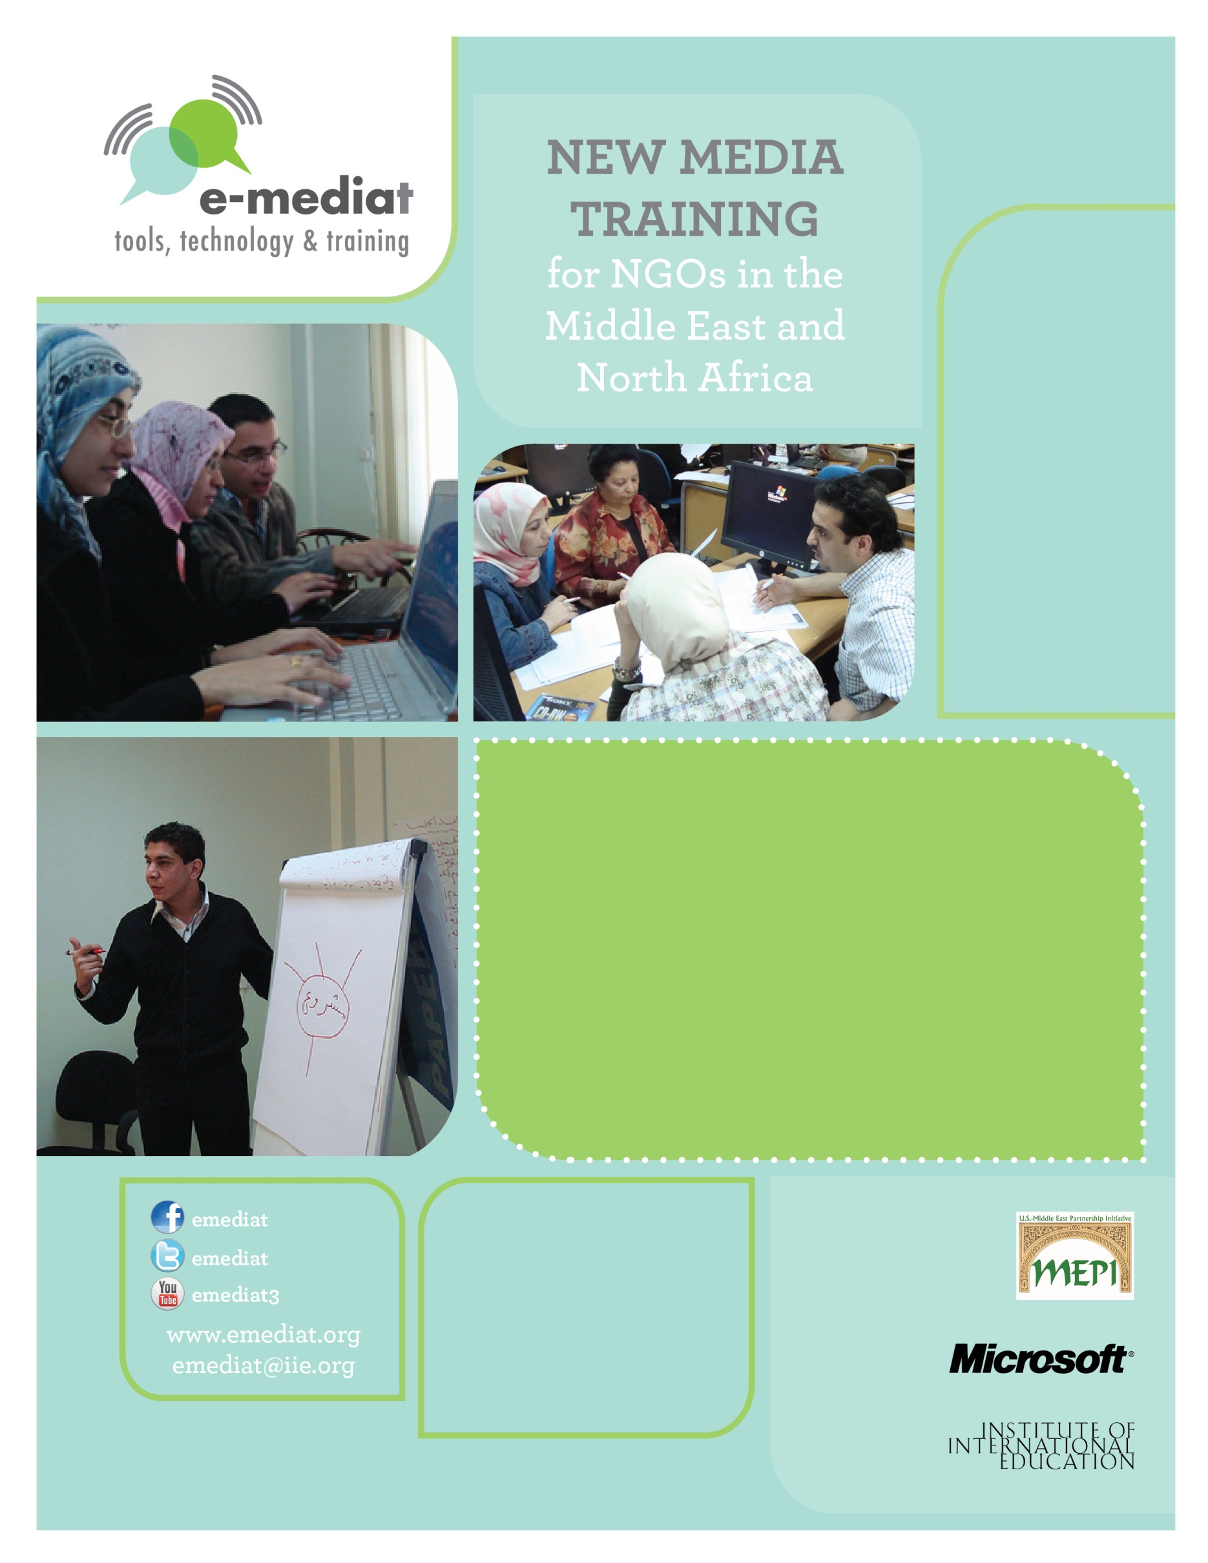
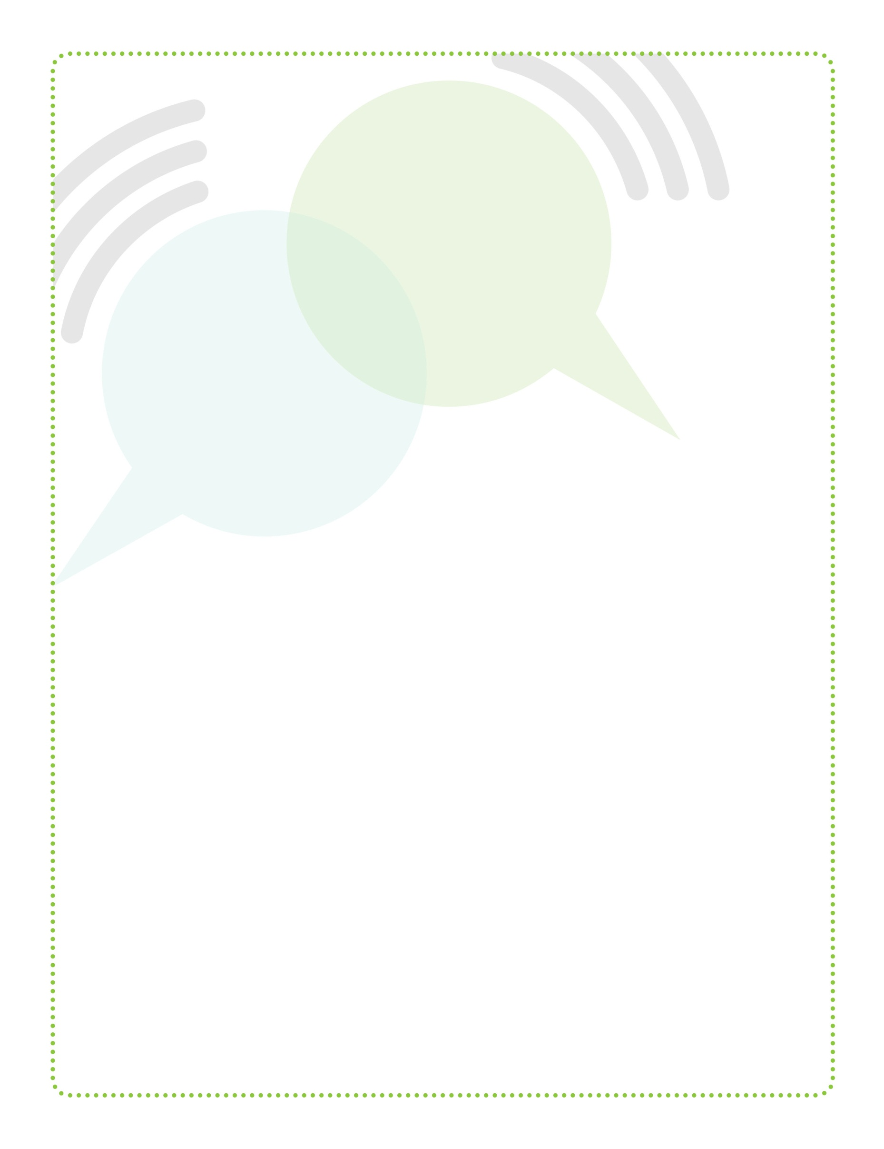

Based on workshops, blog posts, and other material created by Beth Kanter
http://www.bethkanter.org

Trainer’s Guide: Workshop 4
Storytelling with Digital Video
E-Mediat: Trainer’s Guide
Workshop 1:
Social Media and Networked NGOs Overview and Strategic Planning
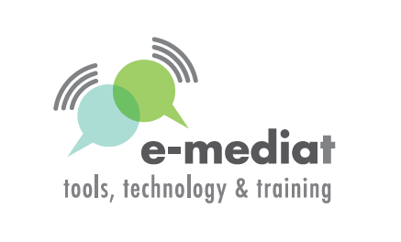

Table of Contents

Overview: E-Mediat Workshops 3
Participant Agenda 5
Day 1: Storytelling through digital video 5
Day 2: Creating, sharing and distributing videos 6
Detailed Trainer’s Outline & Worksheets 7
Day 1: Storytelling through digital videos 7
Day 2: Creating, sharing and distributing videos 13
Appendix 23
Text for Workshop introduction video 23
Tips for shooting videos from Flip Camera 24
Ladder of engagement 25
Linking video to SMART Objectives 26
Storytelling worksheet 27
Interview worksheet 29
Practice shooting one-minute interview 30

Overview: E-Mediat Workshops

Workshop | Description
Workshop 1: Social Media & Networked NGOs Overview and Strategic Planning  Day 1: Introduction to social media for civil society and networked NGOs: Principles of  best practices in social media  Day 2: Creating your social media strategy plan  Day 3: Coaching in small groups and one-on-one for NGOs and CSOs: Training on how to use OLC | Day 1 is an overview of social media and examples. Day 2 provides a framework for creating a social media strategy plan. Day 3 is focused on coaching NGOs on their plans in addition to training on the Online Learning Community.
Workshop 2: Listening and Web Presence  Day 1: Listening, security, and privacy  Day 2: Strategic internet presence: Blogs  and/or websites | Day 1 shares techniques and tools for scanning and listening on social media channels, including how to set up and use a simple listening dashboard. Day 2 focuses on how to improve an existing web presence and/or setting up a blog, so they serve as an online home base for the NGO and links to the social media strategy plan.
Workshop 3: Social Networks  Day 1: Using Facebook strategically for NGOs  Day 2: Using Twitter strategically for NGOs | In workshop 3, participants will learn how to use Facebook and/or Twitter and link to their social media strategy plan. If Twitter is not relevant for the participants, the Facebook workshop can be delivered in two days – with hands-on time and shoulder-to-shoulder learning.
Workshop 4: Storytelling with Digital Video  Day 1: How to use simple video tools to support your social media strategy plan (Part I)  Day 2: How to use simple video tools to support your social media strategy plan (Part I) | This hands-on workshop will teach participants how to use storytelling principles to create compelling videos that can be part of a content strategy for a blog, website, or Facebook. Participants will learn how to use simple video tools including flip camera, editing software, and YouTube.
Workshop 5: Mobile Strategy  Day 1: An overview of text messaging campaign and the mobile generation  Day 2: Sharing social media strategy plans and learning | Workshop 5 will provide an overview to mobile tools and the mobile generation. As the last workshop, participants will have the opportunity to showcase their social media strategy plans and share what they have learned.

For each Workshop Day, the Trainer’s Guide will include:

1. Participant Agenda: This one page handout is a simple version of the agenda which includes times and session titles. This document can easily be printed and distributed to participants.

2. Trainer’s Agenda/Outline: This section will be a detailed version of the participant agenda and include learning goals, times/titles, and the following detailed information:
- Learning goals
- Content to share
- Timing
- Instructions for the trainer on how to facilitate a discussion or lead an exercise
- Description of materials, such as checklists, PowerPoint decks, or additional resources

3. Workshop Materials:
- PowerPoint Deck: The entire workshop will be in one PowerPoint deck. Additional detailed notes about what to say and points to cover will be included in the notes section of the slide. You should print a notes version of the PowerPoint, which will include talking points and additional instructions for your presentations.
- Templates & Worksheets (If word document, this will follow the trainer’s outline)
- Online Resources (http://emediat.wikispaces.com/Tool+Box) and the Online Learning Community (OLC)

Participant Agenda

Day 1: Storytelling through digital video

Learning Objectives

- To introduce frameworks for digital storytelling for NGOs
- To understand what makes a good NGO video and the process of creating one
- To introduce basic shooting techniques and practice with Flip camera

Schedule

9:00 – 9:30 Introduction, agenda review and Icebreaker

9:30 – 11:00 Why videos? Best practices from NGOs

11:00 – 11:15 Break

11:15 – 12:15 Using videos for storytelling

12:15 – 1:15 Lunch
1:15 – 1:30 How to use Flip camera
1:30 – 2:45 Hands-On Time: shooting your video
2:45 – 3:00 Break
3:00 – 4:45 Share participant videos
4:45 – 5:00 Reflection exercise

Day 2: Creating, sharing and distributing videos

Learning Objectives

- To learn to use Movie Maker
- To understand the basics of setting and using a YouTube Channel

Schedule

9:00 – 9:30 Overview of creative process

9:30 – 11:30 Introduction to Movie Maker

11:30 – 11:45 Break

11:45 – 12:45 Hands-on time: upload and edit video on Movie Maker – Part I

12:45 – 1:45 Lunch
1:45 – 2:45 Hands-on time: upload and edit video on Movie Maker – Part II

2:45 – 3:15 Creating YouTube account and uploading videos

3:15 – 3:30 Break

3:30 – 4:45: Share and distribute videos

4:45 – 5:00 Reflection and closing

Detailed Trainer’s Outline & Worksheets

Day 1: Storytelling through digital videos

Learning Objectives
- To introduce frameworks for digital storytelling for NGOs
- To understand what makes a good NGO video and the process of creating one
- To introduce basic shooting techniques and practice with Flip camera

9:00-9:30 Introduction, agenda review and icebreaker

- Exchange ideas through share pairs
  - Ask participants to find partners in the room and answer the following question below. Remember, when you raise your hand, participants should stop interacting.
  - What is one thing you already know or want to learn about use of videos in social media?

- Show Field Team video outlining the agenda of the Workshop
Note: For Field Teams only: you can record a video using Flip camera that highlights the Workshop agenda. Basic text for the introduction is provided in Resource Sheet 1 but you may need to localize it.

9:30-11:00 Why videos? Best practices from NGOs
- Why NGOs use videos
Video has become an important and powerful tool for organizations that want to create change. Whether they are using those videos to raise money, recruit volunteers, or advocate for their causes, the medium can carry emotional impact in ways that other media cannot. As you go through this section, be prepared to show video clips to illustrate your example. Feel free to use local videos rather than those listed below.
- NGOs use videos in many different ways to achieve the organization’s goals or create public awareness. The Red Cross blood donation video “Be a Hero” combines several messages in a single video: benefits of blood donation, process, and experience of first time donors. The video basically walks you through the donation process. http://www.youtube.com/watch?v=bPEk6ZX8kUs. Susan G. Komen for the Cure video explains the problem of breast cancer, objectives of the Komen program and its successes. http://www.youtube.com/watch?v=mdlRf71ncKU
- Large NGOs spread their message through more localized videos. Maghreb team of The Global Rights worked with local partners to create a video of their three week caravan to mobilize support for legislation combating violence against women. http://www.youtube.com/globalrights1#p/u/4/6oF8j8ju6bo
- Videos can communicate your organization’s message to large audiences in more personalized ways. You can make an emotional connection with your sponsors, target audience and potential volunteers. Images and music in a video help you to transcend language barriers and connect to a global audience. Once you upload your organization’s video on a sharing site like YouTube your message will reach to millions; even if they can’t comprehend your languages they will be able to comprehend the emotion in the video.
- How can videos help NGOs
Nonprofits are using videos in a variety of ways to reach wider audiences. See examples below:
- Putting a face on the cause
NGOs usually communicate their cause through mission statements which are abstract and text heavy; videos put a face on the cause. You might talk about child literacy, women empowerment or environmental protection, but the appeal for your cause is much stronger if you show a child working in a brick factory rather than going to school; more people will be moved if you make a visual impact through women suffering from domestic violence; you will win more supporters if you can demonstrate through video sequence the impact of our carbon footprint on the environment. The carbon footprint video by Discovery Channel is a great example of how videos communicate abstract messages: http://www.youtube.com/watch?v=D8-eCbDbu-8
Videos sometimes communicate much more than words. For example the Humane Society of the United States used Stallone, a dog rescued from a dogfighting operation in 2009, to tell about the toll of dogfighting in a way statistics could not. http://video.humanesociety.org/video/629262638001/Channels/602022758001/Animal-Fighting-Cruelty/780714542001/Stallone-The-Face-of-Dogfighting/

- Tearing down walls
Videos help to take your message where you or your organization can’t go. There may be many people interested in your organization’s work but can’t make visits to share the experience. You can take your message and information about your organization’s programs and accomplishments to groups and individuals across the globe through videos. Many museums and education groups are putting parts of their exhibits online so you can experience them anywhere. The Mutter Museum, part of the College of Physicians of Philadelphia, has taken its collection of medical instruments—and medical anomalies—online with a series of videos featuring its director and curator. (http://www.youtube.com/user/Themuttermuseum) In the videos, like these, staff members showcase interesting pieces from their collections to virtual visitors around the world. The one-on-one lessons are surprising, fun, and sometimes creepy. In a similar way, the Anne Frank House in Amsterdam is sharing clips from its archives to an audience around the world, including an interview with the Holocaust victim’s father, Otto Frank and the only available footage of Anne Frank herself. The Anne Frank footage has been viewed more than 2.9 million times. (http://www.youtube.com/watch?v=AWRBinP7ans&feature=youtu.be).

- Showing personal stories
NGOs work on issues that affect millions of people but they possibly can’t capture the entire target segment in a video. Sharing personal stories is the best way to make connections and create awareness about the cause. First Graduate, a nonprofit that works to help first-generation college students earn their degrees, turns the camera on each graduating class, giving students the opportunity to share their stories. http://www.youtube.com/watch?v=ha4wzew2JCg&feature=player_embedded

- Sharing the fun
Many online viewers aren’t interested in watching videos about social causes on YouTube. Instead, they want to laugh and be entertained. And some nonprofits have done a great job of creating entertaining videos that also have a connection to their missions. The Best Friends Animal Society, for instance, uses its collection of cute animals quite effectively in its videos. Other organizations, like Massachusetts’s Children’s Museum in Easton, share small moments from their programs that might make you smile. http://www.youtube.com/watch?v=7KksfV4Fi54&feature=youtu.be

- Saying thank you
Videos are a great way to show appreciation for your supporters and donors. Beth Kanter shares the creative thank you videos used by NGO Charity Water. http://www.youtube.com/charitywaterthanks#p/u/3/HeB2DzMBbKQ According to Beth even though charity water has over 200,000 supporters, they have not lost sight of the critical importance of saying thank you in a personal way to continue to build their network.

- Advocacy Video
Videos for advocacy have caught the attention of nonprofits in recent years. From media freedoms to women’s rights, from campaign against child labor to fostering human rights there are several examples of using videos to advocate support for social issues. Call+Response video from CNN’s Freedom Project makes a strong advocacy against modern day slavery. The video reveals surprising facts and calls for immediate action. http://www.youtube.com/watch?v=XTvyEa9c8Is

- Broadcast live event
Nonprofits connect to their audience in real time by streaming their organization’s events live using Ustream or Livestream. Livestream videos are also saved for audience to view at later times. The Nonprofit Technology Network streams many events on Livestream.

- Public service announcements
Nonprofits work to raise awareness of an issue, affect public attitudes and stimulate action through public service announcements. PSAs are more about creating public awareness and don’t focus on your organization solely. City Harvest, New York created a simple video to raise awareness about food waste. http://www.youtube.com/watch?v=AsFEVyTuMUU&feature=player_embedded

- Animation
Many nonprofits use animation to simplify complex messages. Use of animation with text and/or audio helps to capture attention and deliver the message in subtle ways. The Girl Effect videos are a great example: http://www.girleffect.org/video

[Parts of this section based on Cody Switzer’s article Four Ways Nonprofits Can Use Video to Create Change: http://philanthropy.com/blogs/social-philanthropy/four-ways-nonprofits-can-use-video-to-create-change/28625]

11:00-11:15 Break

11:15-12:15 Using videos for storytelling
- Why is storytelling important?
Before moving to the relevance of digital storytelling, let’s talk about the importance of storytelling for NGOs. Why do NGOs need to tell stories? Stories are a great marketing tool used by for-profit and non-profit organizations. Television commercials for several products use the storytelling framework. “Meet Ted” in the Gain laundry detergent is simply a story about a guy who messes up his clothes and then Gain detergent helps clean the mess easily. http://www.youtube.com/watch?v=DCMvy_88SQw
Note: Again, you are encouraged to use examples from local commercials if you feel it can illustrate your point effectively.
Why do most of us effortlessly remember many television commercials? Because the commercial tells a story that we can identify with. So telling a story is the easiest way to get out the message and attract a larger audience. Stories help to make connections and leave lasting impressions.
- Types of Stories
NGOs can tell three types of stories to communicate their message.
- The story of self (organization) – this is the story about the organization’s mission, objectives, strategy or accomplishments. You could also tell stories through you organization’s staff, their motivations and experiences.
- The story of us (community) – this is the story of the target group with/for whom the organization is working – women, youth, children, civil society, journalists or people with health problems. The story is a narration of their challenges and impact of your organization’s work on their lives.
- The story of now (change the world) – this is the story of your cause. This helps to connect your organization’s work to similar efforts across the globe. You can connect to donors interested in causes that your organization supports. This story helps to communicate that your organization is in its own small way making a difference that would help to promote a particular cause.

- Digital Storytelling
As emphasized during the last session, videos are an important medium for NGOs to connect to the audience. Given the potential of the medium it is advisable to plan the content for your video. Storytelling is the most commonly used framework for NGO videos. You can amplify the impact of your story by creating a video and distributing it widely.

Today, with social media, the way stories are being shared is changing dramatically. Storytelling 2.0 incorporates best principles of good storytelling, as modeled by blockbuster Hollywood scripts and fairy tales and also effectively leveraging social media. This enables your story to go “viral,” when your audience and others pass it along for you, and integrates valuable user-generated content. Stories are now open-ended conversations, participatory, experimental, and as mentioned earlier, many times not created by the nonprofits themselves. Social media makes creating, remixing, and sharing stories between nonprofits and their stakeholders easy and fluid. It also expedites generation of these stories and augments opportunities for participation, while revealing new opportunities for nonprofits to communicate and connect with new stakeholders.

- Tips for digital storytelling
The following tips will help participants to structure their storytelling framework before they record their first video.
- Choose a story and video genre. Before producing anything, decide what your narrative is. What is the message you are trying to deliver? Decide what kind of video you want – interview with a stakeholder, introduce your organization, create awareness about the cause or share experiences.
- Keep it short. Powerful videos are often under 2 minutes long, at most no longer than 3 minutes. The effort you put into keeping it short will go a long way in helping you focus your message.
- Keep it simple. Try to focus on one main topic i.e. an event, one person’s story, a lesson, a testimonial. It’s easier to get excited about a video that is focused.
- Be genuine. Viewers want to connect with the work that your organization is doing. Focus on content that is compelling rather than what’s “cool”. It isn’t just making the video; it is also about sparking conversation.
- Keep it fluid, Beginning-Middle-End. Catch the audience at the beginning and explain what is happening, build emotion in the middle and come to some sort of resolution at the end.
- Keep it moving, audio. Video shows the story but don’t forget the importance of audio. Audio adds emotion.
- Check legal issues. In the US, if you are creating the video on behalf of your nonprofit, you have to abide by legal issues and get permission in writing to take a photo or video of someone and post them on the Internet. This may or may be not be the case in your country. Make sure you have a video-release form for anyone appearing in your video. Check local laws before shooting anything and be sure to always have releases handy. When in doubt, get a release signed.
- Respect privacy and security. Not everyone wants a video camera shoved in their face and their image on YouTube. Get permission first. If the video could endanger someone, don’t show their face or shoot so it is backlight (we’ll explain in more depth later). Don’t put the person’s name on the video.
- Give credit. If you use an image or resource created by someone else, give credit and link to the original creator.

12:15-1:15 Lunch

1:15-1:30 How to use your Flip camera

- Participants to be introduced to basic features of Flip camera with help of this video:
http://www.youtube.com/watch?v=mh6s9gNoFro
- Show the participants manually how to use the controls on the Flip camera .
- Explain how the video from the camera can be transferred to the computer via the USB port.

1:30-2:45 Hands-on time: shooting your video

Helpful tips for shooting your video
- Participants will work to record short (2-3mins.) movies using their flip camera
- They can choose from the following themes
- Introduce your organization: Talk about your organization’s mission statement, number of people involved, current projects, target groups and geographical reach
- Speak about the cause that your organization supports: Talk about the significance of cause that your organization supports. For example, you can focus on women’s empowerment, environmental protection, workforce development, education etc.
- Highlight a successful project/program of your organization: You can talk about a any recent/ongoing project that highlights your organization’s accomplishments
- Share your experience of E-Mediat Workshops: Feel free to share your experience of E-Mediat training workshops Optional
- Thank you videos
- Options for the video themes can be localized
- After choosing your theme, prepare your video pitch: Collect your thoughts and write it out carefully
- Using the flip camera do a short mock video. View the test video and make any changes that you think will improve quality of video. Be sure to choose the right location and capture enough light and good quality sound
- Record your video!

2:45-3:00 Break

3:00-4:45 Make simple edits and share videos
- Transfer videos from Flip camera to your computer
- Induct the Flip camera on the computer’s USB port
- Save file from camera to computer
- Highlight the files you want to save and click on save
- You can make basic edits to the video
- Click create movie, drag your clip into the create movie screen
- Click full length
- Check include title
- Check include credits
- The default is to save it in your monthly folder or you could create and name folders
- The bar on left hand corner indicates that movie making is in progress
Note: We will learn about more sophisticated software for editing on Day 2 (Movie Maker)
- Ask participants to play their videos and share what changes they made after the test video

4:45-5:00 Reflection exercise

- Do a series of “Share Pairs” where people ask and answer these questions:
- What did you learn today?
- What still isn’t clear?
- What do you need to move forward?
- What is the most important thing you want to learn tomorrow?
- Then gather in a circle and have everyone share one word about how they are feeling and why

Day 2: Creating, sharing and distributing videos

Learning Objectives
- To learn to use Movie Maker
- To understand the basics of setting and using a YouTube Channel

9:00-9:30 Overview of creative process

This session provides an overview of the creative process from concept to strategy.

Strategy: It is important to align your videos to your social media plan. Link video to SMART objectives Worksheet will help participants to do so. Participants should be encouraged to think through how they will use the video to support the organization’s social media and communication objectives, identify potential stories, how they might package them – a series or stand alone, where to cross post, and think about the last step – sharing.
Shooting: This is what you did using your flip camera on day 1. While shooting you will have to keep in mind issues like framing, lighting, audio quality and lightning (For more on shooting tips refer to Resource Sheet 2).
Editing: Whether you are using the simple software with the Flip camera or fancy software, you will need to some editing. With the flip camera, it is best to do “in-camera editing” – that is, shoot only what you’ll actually use. We’ll cover simple editing such as adding titles and credits. We’ll also learn how to edit out or “cut” part of a clip to make it shorter or only get a good part. We will talk more about editing during the Movie Maker session.
Publish and share: Publishing is about uploading a video on YouTube and other outposts. Set your videos free – publish to more than one location. You also need to think about your ladder of engagement - how you will cross post your stories to other channels and get people excited about the video and share with others. (For ladder of engagement refer to Resource Sheet 2)
Listen: Don’t just focus on your story, encourage your network to share their stories about your organization’s work. Encourage responses and invest time in the feedback loop through blog and Facebook comments. This will help you to develop a better understanding of what is being said about your organization, cause or program on the web and in the community.

9:30-11:30 Introduction to Movie Maker
Windows Movie Maker is a feature of Windows Vista that enables you to create home movies and slide shows on your computer, complete with professional-looking titles, transitions, effects, music, and even narration.
- Features: Windows Movie Maker is divided into three main areas - the panes, the storyboard/timeline, and the preview monitor.
- The contents pane shows clips, effects, or transitions you're working with while you create your movie, depending on the view you're working with. You can change the view to show thumbnails or details. You can drag clips, transitions, or effects from the contents pane or a collection from the collections pane to the storyboard/timeline for your current project. You can also drag clips to the preview monitor to play them. If you make changes to a clip, those changes are only reflected in the current project; they do not affect the source file.
- The storyboard is the default view in Windows Movie Maker. You can use the storyboard to look at the sequence or ordering of the clips in your project and easily rearrange them, if necessary. This view also lets you see any video effects or video transitions that have been added. Audio clips that you have added to a project are not displayed on the storyboard, but you can see them in the timeline view.
- The timeline view provides a more detailed view of your movie project and allows you to make finer edits. Using the timeline view you can trim video clips, adjust the duration of transitions between clips, and view the audio track. You can use the timeline to review or modify the timing of clips in your project. Use the timeline buttons to switch to storyboard view, zoom in or out on details of your project, narrate the timeline, or adjust the audio levels.
- Import a Video Clip into Windows Movie Maker
- You can import a video clip into a brand new Windows Movie Maker project or add a video clip to an existing movie in the works.
- Important - Make sure that all components of this project are saved in the same folder.
- In the Tasks pane on the left side of the screen, click on Import video under the Capture Video section.
- Once you have chosen to import a video clip in the previous step, you now need to locate the video clip saved on your computer.
- Navigate to the folder that contains all the components of your movie.
- Click on the video file you wish to import. Such file extensions as AVI, ASF, WMV OR MPG are the most commonly selected video types for Windows Movie Maker projects, although other file types can also be used.
- Check the box to Create clips for video files. Videos are often comprised of many small clips, which are marked by the creating program when the file is saved. These smaller clips are created when the video process is paused or there is a very obvious change in the filming. This is helpful to you, as the video editor, so that the project is broken down into smaller, more manageable pieces.
- Not all video files will be broken into smaller clips. This depends on which file format the original video clip was saved as. Checking this box to create clips for video files, will separate the imported video clip into smaller clips, if there are obvious pauses or changes in the original video clip. If you choose not to select this option, the file will be imported in as a single video clip.

- Preview the Video Clip in Windows Movie Maker
- Click on the new video clip icon in the Collections window.
- Preview the imported video clip in the preview window.
- Drag Imported Video Clip to Storyboard
- Now you are ready to add this imported video clip to the movie in progress.
- Drag the video clip icon from the Collections window to the desired location in the storyboard.
- Note - If you wish to place the video clip in a location that already contains another object, such as a still picture, simply drag the imported video clip just before the other object on the storyboard. This will insert the video clip before that object.
- Save the Windows Movie Maker Project
- Once the video clip has been added to the storyboard, you should save your new movie as a project. Saving as a project allows for further editing at a later time.
- Choose File > Save Project or Save Project As, if this is a new movie project.
- Navigate to the folder that contains all of the components for your movie.
- In the File name text box, type a name for this movie project. Windows Movie Maker will save the file with a file extension of MSWMM to indicate that this is a project file and not a completed movie.

- Edit video clips
- Change to Timeline View to Edit Video Clips
- Now that you have imported your video clip into Windows Movie Maker in the previous tutorial, you now have the option to edit that video clip, by deleting portions of the clip or trimming it to a smaller size.
- Click the Show Timeline button to switch to the Timeline view of Windows Movie Maker.
- Zoom In to Edit Video Clips
- In the Windows Movie Maker Timeline, click the Zoom In button (click once or several times) to enlarge the video clip. This will make it easier to fine tune your editing.
- Windows Movie Maker Preview Screen Buttons
- The Windows Movie Maker preview screen shows the complete movie in progress. The buttons below the preview screen operate as follows:
- Play button - becomes a Pause button once the movie is in progress.
- Stop - The small square is the Stop button.
- Fast Rewind - This button skips the movie back to the beginning.
- Previous Frame - This button will move the movie backwards, frame by frame. This is helpful to zero in on exactly the correct frame of the movie.
- Next Frame - This button will move the movie forward, frame by frame. This is helpful to zero in on exactly the correct frame of the movie.
- Fast Forward - This button skips the movie to the end of the last frame.
- Pause the Video to Edit the Video Clip
- Click the Play button to start the video clip.
- The Play button toggles to become a Pause button. Click the Pause button at the appropriate frame to edit the video clip.
- Split Video Clip at Selected Frame
- Once the video clip is paused at the correct frame, you can split the current video clip into two parts.
- Choose Clip > Split or use the keyboard shortcut keys Ctrl + L
- The video clip is now split into two sections.
- Split the Video Clip at a Second Location
- The video clip is now split into two sections.
- Click the Play button once again to advance the video clip.
- Press the Pause button when the video clip reaches the spot where you want to split again.
Note - Instead of playing the clip, you may choose to advance the video clip frame by frame, by using that button. (Refer to step 3 for a description of the Forward and Rewind buttons.) This will allow you to reach the precise location to make the next split.
- The original video clip should now be split into three sections.
- Delete Video Clips in Windows Movie Maker
- In the Timeline view or Storyboard view (either will work), click on the portion of the video clip you wish to delete.
- Press the Delete key on the keyboard. The unnecessary part of your video will be deleted and the remainder of the video clip will move to the left to take up the empty space.
- Trim Windows Movie Maker Video Clips
- You may wish to trim the length from a video clip, (rather than delete that portion), to hide those portions of the clip from view. This can be done at either the beginning or end of any video clip.
- In the Timeline view of Windows Movie Maker, click on the video clip to select it.
Note - You might consider zooming in on the video clip for more accuracy.
- Hover the mouse over the end (or beginning) of the video clip. The mouse point becomes a red, double headed arrow.
- Drag the mouse to the left (to shorten from the end), or to the right (to shorten from the beginning) of the video clip. As you drag the mouse, the portion you will be keeping will turn dark blue. When you release the mouse the clip will be trimmed.
- Note - Although you have trimmed the video clip, the trimmed parts are still there, but hidden from view.
- How to Return the Video Clip to its Original Size
- Click on the trimmed video clip to select it.
- Choose Clip > Clear Trim Points from the menu.
- The video clip will be returned to its original size.

- Adding music and sounds
- Importing an audio file
- Any music, sound file or narration file is known as an audio file.
- Under the Capture Video link, choose Import audio or music.
- Locate the folder containing your audio file.
- Select the audio file you wish to import.
- Once the audio file is imported, you will notice the different type of icon in the Collections window.
- Add an Audio Clip to the Timeline
- Drag the audio icon to the Storyboard.
- Note the message box indicating that audio clips can only be added in the Timeline view.
- Click OK in this message box.
- Audio/Music Timeline
- Audio files have their own location in the Timeline to keep them separate from pictures or video clips. This makes it easier to manipulate either type of file.
- Align the Audio with a Picture
- Drag the audio file to the left to align with the start point of the first picture. This will start the music when the first picture appears.
- Timeline View of the Audio Clip
- The Timeline indicates how much time each item takes up over the course of the whole movie. Notice that this audio file takes up a much bigger space on the Timeline than the pictures. Scroll across the Timeline window to see the end of the audio clip.
- In this example, the music ends at approximately 4:23 minutes, which is much longer than we need.
- Hover the mouse over the end of the music clip until it becomes a two-headed arrow. Drag the end of the music clip to the left to line up with the last picture.
- Note - In this instance, I will have to drag the end of the music clip several times to reach the beginning of the movie due to its size. It is easier to do this if you zoom in on the timeline so that there is not so much dragging. The Zoom tools are located at the bottom left side of the screen, to the left of the Storyboard / Timeline.
- Music and Pictures are Lined Up
- Now the music clip is lined up with the pictures from start to finish.
  - Note - You may choose to start the music at any time in your movie. The music clip does not have to be placed at the beginning.
- Save the movie.

- Add narration to your movies
- Find the starting place for narration
- Drag the Playhead
- Once you have added the photos or video clips to your Windows Movie Maker movie, you may wish to add some narration. Perhaps this is a documentary type of movie you are making, so you may even want to narrate the whole movie.
- The first consideration is where to start the narration in the movie.
- Switch to Timeline view of the movie if the timeline is not already visible.
- Choose View > Timeline from the menu or click on the Show Timeline button just above the Storyboard area of the movie.
- Drag the playhead to the location on the Timeline where you would like to begin the narration.
- Microphone Icon
- In the Timeline pane at the bottom of the Windows Movie Maker screen, click the microphone icon to begin the narration process.
- Narration Options
      - If this is your first time using the narration feature in Windows Movie Maker, you may want to have a look at the additional options for narration.
      - There are several things you can do to get the best narration for your movie.
      - Input level - allows you to adjust the volume of the audio that you will capture. Drag the Input Level slider button up a little towards the top, but not into the red area. That will produce a loud and distorted narration. Setting the slider too low, will make the narration difficult to hear. You may have to experiment a little to get the best results.
      - Audio device - allows you to choose a specific device for the recording of the narration, if there is more than one installed on your computer.
      - Audio input source - lists any audio devices that are attached to your computer, such as a microphone.
      - Limit narration to available free space on Audio/Music track - If you choose to add a narration between two audio clips currently on the Timeline, you should check this box.
  - your narration will be limited to the available space between these two audio clips
  - those clips will not shift if the narration is too large for the space
  - the narration will stop automatically once the space is filled.

- Mute speakers - This is a good option to check if there is other music or audio that will play at the same time as the narration. This will ensure that your narration is clear and not hindered by the background music, while you are recording.
- Start Narration - Once all options are selected, click the Start Narration button to begin recording. Once your narration is complete, click on the Stop Narration button.
- Narration File Type
- Once you have stopped the narration, you will be prompted to save the narration file.
- Locate the folder on your computer where you will save the file.
- Type a name for the narration file in the File name text box.
- The narration file type is a Windows Media Audio. The file extension .WMA will be added to the end of the filename.
- Narration Clip Added to Timeline
- Once the narration file is saved, the narration clip is automatically added to the Windows Movie Maker Timeline.
- Narration is Complete
- Once the narration is complete, click the Done link to return to the main Windows Movie Maker Window.
- Once the narration recording is saved, the narration clip is added to the Collections window at the top of the screen. Notice that the icon is an audio type.
- Test your narration in the movie, by clicking on the Play button. If you do not like the results, simply delete the narration in the Timeline and record again.
- Narration Clip
- Once the narration recording is saved, the narration clip is added to the Collections window at the top of the screen. Notice that the icon is an audio type.
- Test your narration in the movie, by clicking on the Play button. If you do not like the results, simply delete the narration in the Timeline and record again.

- Video Transitions and Video Effects
- Change to Storyboard View
- Open your Windows Movie Maker project file.
- If Movie Maker opens in Timeline view, return to Storyboard view by clicking on the Show Storyboard link.
- Access Video Transitions
- In the Movie Tasks section, click on the Edit Movie drop-down arrow to show available options.
- Select a Video Transition
- Select your first picture in the Storyboard.
- Scroll through the video transitions and select one. You can see the effect by clicking the Play button on the Preview screen. Test out several and make your final choice.
- Apply the Video Transition
- When you have chosen the video transition, drag it to the Storyboard between the two pictures

- Apply Video Transitions
- To apply a video transition to each picture, repeat this process dragging transitions between each picture. You may use the same transition for all pictures, or choose different transitions.
- Preview your movie.
- Add Video Effects
- Video effects can also be added to your movie. A video effect applies to the picture itself rather than the change from one picture to another as in a transition.
- Choose View video effects under the Edit Movie section and drag the chosen effect to the star in the lower left corner of the picture.
- Preview your movie to see the effects.
- Continue to add effects to other pictures if desired.
- Save the file.

- Titles and Credits
- Choose titles and credits from menu
- Under the Edit Movie section, choose Make titles or credits.
- Choose a Location
- You have several options for where to place your Windows Movie Maker title and credits. They may precede or follow a picture or video clip, or be used as an overlay.
- In this example, I have chosen to place the title at the beginning of this movie.
- Titles and Subtitles
- Enter your movie title and a subtitle if desired.
- Check out the other options available. You can change how the titles appear and the font and colors of the title page.
- Title Preview
- Your movie shows in the preview window on the right.
- When you are satisfied with the changes, click on the Done, add title to movie link.
- When you return to the main window, preview your movie.
- Closing Credits
- Repeat the procedure to add a title, but instead, choose to add credits to your movie.
- You will notice that any font or color changes you made for the title are still in place to keep the movie unified. However, you have the option to change any or all of these features.
- Don’t forget that now that you have added a title and credit page, you may wish to add transitions to these as well. Return to the Storyboard and add these now.
- Save the project.
- Save as a Movie
- Now that your movie is complete, you may wish to save the project in a different format. Saving the project and saving the movie are two different things.
- The movie project is the working file so that you may continue to edit until you have a final version of your work completed.
- The movie file is the final output of your movie. Windows Movie Maker compresses all the parts of your movie into a single unit. The file size is much smaller so that it can be used on a web site or emailed.
- You also have the option to create a CD or DVD of your movie. These options are all under the heading Finish Movie
- It is always a good idea to keep your project file readily available. You cannot edit a compressed movie file. If you find that you wish to edit your project file for any reason, you can always make a new movie file.

Resource
Video tutorial on using Movie Maker: http://www.youtube.com/watch?v=JZXK68NS7gU

11:30-11:45 Break

11:45-12:45 Hand-on time: upload and edit video on Movie Maker – Part I
- Participants can upload their videos from day 1 to the movie maker
- They might also add supplemental photos to the video, add music or special effects
- Allow participants to play with the various features of Movie Maker to edit and improve their video quality

12:45-1:45 Lunch

1:45-2:45 Hands-on time: upload and edit video on Movie Maker – Part II
- Allow additional time for participants to add finishing touches to their videos.

2:45-3:15 Creating YouTube account and uploading videos

- Steps for setting up a YouTube account
- Go to YouTube.com and click the Sign Up link
- Enter your e-mail address and a password
- Fill in the Re-type Password and Username fields
- In the Location drop down list, select the country where you live
- Enter your postal code
- Click to select your gender
- Type the characters from the colored box into the Word Verification filed
- Check the terms of Use, Privacy Policy box after you read all the legal terms.
- Click the Create My Account button

- Show video on uploading to YouTube: http://www.youtube.com/watch?v=9w-gQAwS2uc

- Steps for uploading video on YouTube
- Click the Upload link at the top of the YouTube page
- Click the Upload video button to browse for the video file you’d like to upload to the site. Select the file you want to upload and click Open
- As the video file is uploading, enter as much information about your video as possible in the relevant files (including Title, description, Tags and Category). You’re not required to provide specific information, but the more information you include, the easier it is for users to find your video
- Click the save changes button to save the updates you’ve made to the video file
- You can upload up to 10 video files in a single uploading session

3:15-3:30 Break

3:30-4:45 Share and distribute videos

- Encourage participants to tweet about their video, add it on their organization’s Facebook account and websites.
- Participants should comment on each other’s videos and suggest improvements.
- Field teams can upload some videos on their Facebook page.

4:45-5:00 Reflection exercise

- Do a series of “Share Pairs” where people ask and answer these questions:
- What did you learn today?
- What is still isn’t clear?
- What do you need to move forward?
- What is the most important thing you want to learn tomorrow?

- Then gather in a circle, and have everyone share one word about how they are feeling and why.

Appendix Resource Sheet - 1

Text for Workshop Introduction Video

(For Field Teams)

Text for Introduction Video
Making uploading videos has never been easier as many smart phones, laptops, or computers come with everything you need factory installed. And with inexpensive digital cameras, like the FLIP and others, you can easily create videos. While including video in your social strategy can help by telling a story more quickly and effectively than printed text, a video that is not well made can just as easily distract. Still, you don’t have to be a professional to shoot, edit, and post a good video.
This workshop focuses on the art of simple, yet effective storytelling with video. While the curriculum for this workshop uses specific tools – Flip camera, editing software, moviemaker and YouTube – the principles and tips are transferable to any camera and editing software. Once participants have mastered the basics with simple tools, you can introduce other editing software and more sophisticated types of videos that build off the basics introduced in this workshop.
We were lucky enough to get a donation of Flip cameras from CISCO for every participant. The Flip cameras make it very easy for anyone to create a video and share it on YouTube. Many nonprofits around the world are using them to tell their stories and you will too. What is nice about the Flip cameras is that they are easy to use – you’ll spend more time actually creating the content and sharing it – than figuring out how to use complicated software and dealing with technical problems.
Even if you don’t have a budget and are stressed for time you can create a account on YouTube and put videos in it. You can use existing video assets, repurposed video assets and make simple videos using a Flip camera or other low-cost consumer product.
This curriculum focuses on telling a good story, but using simple tools. You can apply the principles to any tools
- Note:
The curriculum for this workshop also allows the in-country teams to model what you have learned used the flip cameras. In addition, the exercises that participants will do during the workshop will help us document the work, build out the curriculum for future years, and also help spread the word about the great work you are doing.
It will be important for all in-country teams to reflect and share what they’ve learned about using the cameras and videos in their social media strategies – especially across the teams. As you modify this curriculum, please be sure to share with each other. We’ve created a page on the emediat wiki for you to do this: http://emediat.wikispaces.com/Workshop+4+Video

Appendix Resource Sheet - 2

Tips for shooting videos from Flip camera

- Framing: the video will be posted on the web, and viewed on little screens, so the closer the shot the better. Faces are great. Don’t be afraid to get up close and personal with people. But DO NOT USE the ZOOM. To “zoom” just step up closer to your subject.
- Wide shots are great for establishing context and place. When you shoot your daily intros, do one wide shot that shows the speaker and some part of the location, and one close shot on the speaker’s face.
- The audio capabilities of this camera are very limited, so if you’re interviewing someone, the closer the better.

- Background: if you have a choice between a white background and anything else – pick anything else! Trees are great.

- Try to shoot with your back to the sun. If you’re interviewing someone, don’t be afraid to ask him/her to move for you so the sun is lighting their face – they’ll look much better in the finished product.
- Resist panning. One slow pan or two to get a feel for a location is fine, but for the most part shoot one subject, scene, whatever and keep the camera focused on it for the whole six- to 12-seconds.
- Fluidity: the goal here is to reduce jerkiness. Think of your body as a tripod. The more solid the base (you), the more solid the shot. Bend your knees slightly; support your elbows with your body; support the camera with both hands. When you pan, move your lower body first, not your torso. Think of north of your waist as a single unit – torso, elbows, arms, hands, camera all turn together. There will be times when you can’t do this and all you have is your hand to support the camera.

Appendix Resource Sheet - 3

Ladder of Engagement

Understand The Ladder of Engagement: From Passive to Active Co-Creation
Think about all the various ways your organization interacts with different groups of people through your communications and fundraising efforts– through social media or other traditional channels. You will undoubtedly discover that some people engage with you lightly, while others dive more deeply. Face it: your audiences will not have the same level of passion or interest in your program as you do. And, that is not a problem— it’s just the way it is.
To be successful using social media, you need to use different techniques, tactics, and tools that map to each person’s level of interest. You need a portfolio of approaches that meet people where they are at, and that help get them more engaged with your efforts. Let’s look at this more
Degree of Engagement | Role in Storytelling 2.0 Content Creation | Description
Very Low | Happy Bystander | Reads your content, views your videos, or joins your Facebook Page or network, but only lurks
Low | Conversationalist | Responds to a conversation starter on your blog, Facebook Page, or YouTube Channel by leaving a comment, rating, or “liking” it
Medium | Promoter | Shares your content with other people
High | Evangelist | Actively encourages other people to participate in the conversation and remixes your content
Very High | Instigator | Creates and shares their own story with friends and others
It is important to understand that these roles and levels of involvement are part of an ecosystem— just like the donor pyramid and ladder of engagement you already read about. Only a few people will rise to the Evangelist or Instigator levels due to the required commitment of time and skills, or because they’re not yet sufficiently engaged in your work. Nonetheless, these supporters are still important to the ecosystem because they spread your stories and demonstrate clear community interest. Recognize and appreciate people where they’re at, and don’t take it personally if they’re not interested in or able to get more engaged as you strive to gently nudge them further down your pipeline.

Resources
Witness Video Guide, http://witnesstraining.wordpress.com
Inspiration for NGO Videos by Beth Kanter, http://beth.typepad.com/beths_blog/2009/06/on-the-road-in-tanzania-un-world-food-programme-video-blog.html
WeAreMedia – Beth Kanter, Curator, http://www.wearemedia.org/Strategy+Track+Module+4

Appendix Worksheet - 1

Linking Video to SMART Objectives

- Summarize your strategy
  - Intent/Results

  - SMART Social Objective

  - Audience

  - Content Strategy and Engagement Strategy

- Brainstorm some ways you could use the FLIP Camera to create simple videos that support your social media strategy
- What are some stories or scenes that you could document on video that illustrate how your organization has achieved results? Would this part of a blog post, post on Facebook, or stand-alone?
- Who could you interview?
- Is there an event, program, or activity that would be used to document with the camera and share on YouTube? Why?

Appendix Worksheet - 2

Storytelling Worksheet

Beginning
Person: The leading character, hero, or heroine in a story. For nonprofits, this person(s) (or animal) should represent someone who benefits from your organization’s services or is affected by the cause your organization promotes.

Person:

Setting: These are the important details that provide context for the protagonist and that describes her/their situation. Again, it’s important to keep this interesting by providing details and personalizing the situation— the goal is for your reader to be able to visualize himself in the storyline.

Setting:

Middle
Tension or Problem: The protagonist encounters a problem. Traditionally this is the guy with the thin moustache, dressed in black, with the evil laugh, but for nonprofit stories, this can be an unexpected event, an act of G-d, or some tension in the protagonist’s life. In order to establish the strength of your lead character, tell the story of how the protagonist tried to solve the problem but was not successful.
Tension or Problem:

Emotion: It’s really important to incorporate emotion into your story. This can be something funny, scary, sad, or whatever is appropriate. In the Food Bank example, this might be sharing how the family’s children were so hungry during school that they couldn’t concentrate, leading to poor performance in school.

Emotion:

End
Resolution: The organization solves the protagonist’s problem in a way that inspires readers to support its efforts to do more of the same. This is where you can widen the lens and bring in overall statistics and trends relating to your program.
Resolution:

Appendix Worksheet - 3

Interview Worksheet

- Write a script and storyboard to produce a “Quick Interview” video. Maybe you want to do a series of interviews or just. Go back to your notes from earlier today and pick something that supports your SMART social objectives.

Name of Subject:
Relationship with your organization:
Why do you want to interview them? How does it support your objective?
What is the title of your video?
Interview questions:

- Write a script and storyboard to produce a “Three Minute Interview” Video.

Name of Subject:
Relationship with your organization:
Why do you want to interview them? How does it support your objective?
What is the title of your video?
Interview questions:

- What is a good establishing shot?

- Where can you film this interview so it is quiet?

- What observational shot that relates to the content of the interview can you use?

- How will you shoot the interview?

Appendix Worksheet - 4

Practice Shooting One-Minute Interview

Description
Participants will work in pairs to practice interview shooting tips with one another following the instructions on worksheet #4. The interviews will be about what they learned so far from E-Mediat that they have put into practice. Each pair will use one FLIP camera. Once they have practiced responding to questions, they can shoot the interview. Each pair will review the video they made of each other in the camera and decide whether or not to reshoot.
Each pair will combine their interviews into one movie using the FLIP camera editing software and add a title. They will upload them to your E-Mediat YouTube Video account, if possible. If the Internet connection is not working, they will export the file from FLIP software and their computer onto a USB stick and the file can be projected from the instructor’s computer or laptop.

Time | Task
30 minutes | Practice each person gets 15 minutes to be the “camera” person to ask interview questions and film them.
30 minutes | Working in pairs, they should combine their interviews into one movie file and add a title and upload to the YouTube account
15 minutes | If Internet is not available, use this time to copy the movie into a USB stick and onto the instructors computer to project with LCD

Quick Interview

Name of Subject:

Interview questions:

What is the most valuable idea you have learned so far from E-Mediat program:
How how has your NGO used it in their work?

What Has Your Organization Learned from E-Mediat?

What is a good establishing shot?
Where can you film this interview so it is quiet?

What observational shot that relates to the content of the interview can you use?

Types of shots
Type | Description
Establishing | Introduces your audience to the location. This could be an extra long shot view of your subject from a distance and/or having them state their name and what they do
Observational | Also known as “B-Roll” shows the interview subject doing something related to the content of the interview. With more you show the observational and have the person talking over it. For the FLIP camera, you can have the person answer the question while they are doing the task or activity.
Interview | This is shot of the person answering the question with their head in the frame in a staged way. You can ask the question off camera and have the person answer it on-camera. If you are doing more than one question, you can switch the camera angle. With the FLIP Camera, very important to get close to subject.

