Approaches to Learning:
Student-Centered Learning | 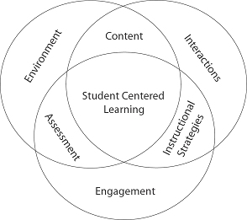 | This approach to education focuses on the needs, abilities and interests of the youth and encourages their involvement in the process.
Engaging Multiple Intelligence  (Engaging more than one way of thinking) | 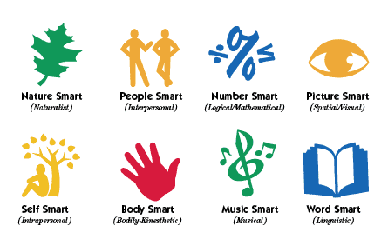 | Using a variety of senses to learn:  Linguistic/Verbal  Logical-mathematical  Musical  Bodily-kinesthetic  Spatial  Interpersonal  Intrapersonal
Experiential Learning | 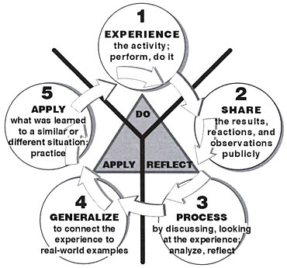 | Learning by doing.  Doing something then reflecting on what you did, apply lessons learned and do again.
Peer to peer learning | 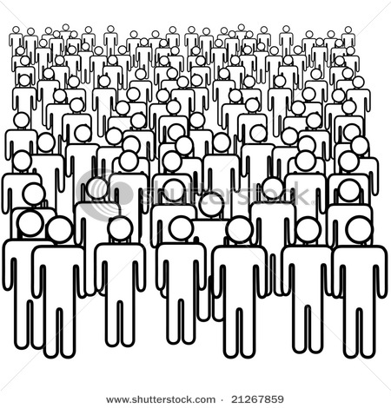 | Research shows that by age  10, young people are far more likely to have their minds changed  by their peers than by their parents or other adult figures in their lives
‘Awakening the Critical Consciousness’  Focus on and emphasis on critical thinking | 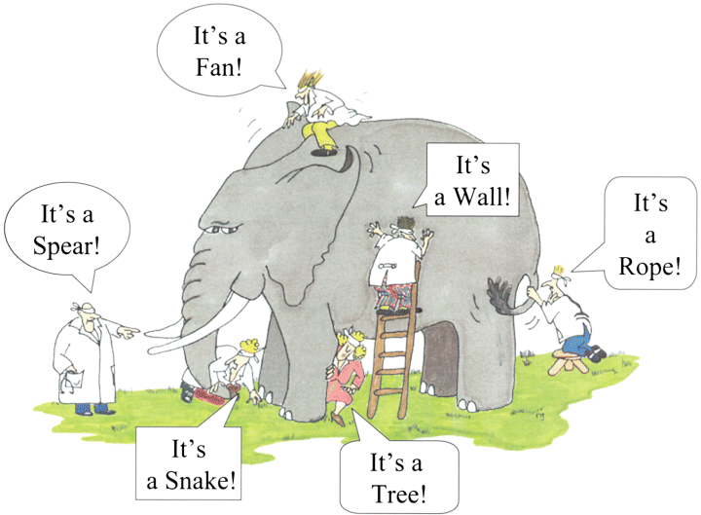 | Development of critical thinking  skills, developing a dynamic understanding of global issues, and building a truly global perspective.

