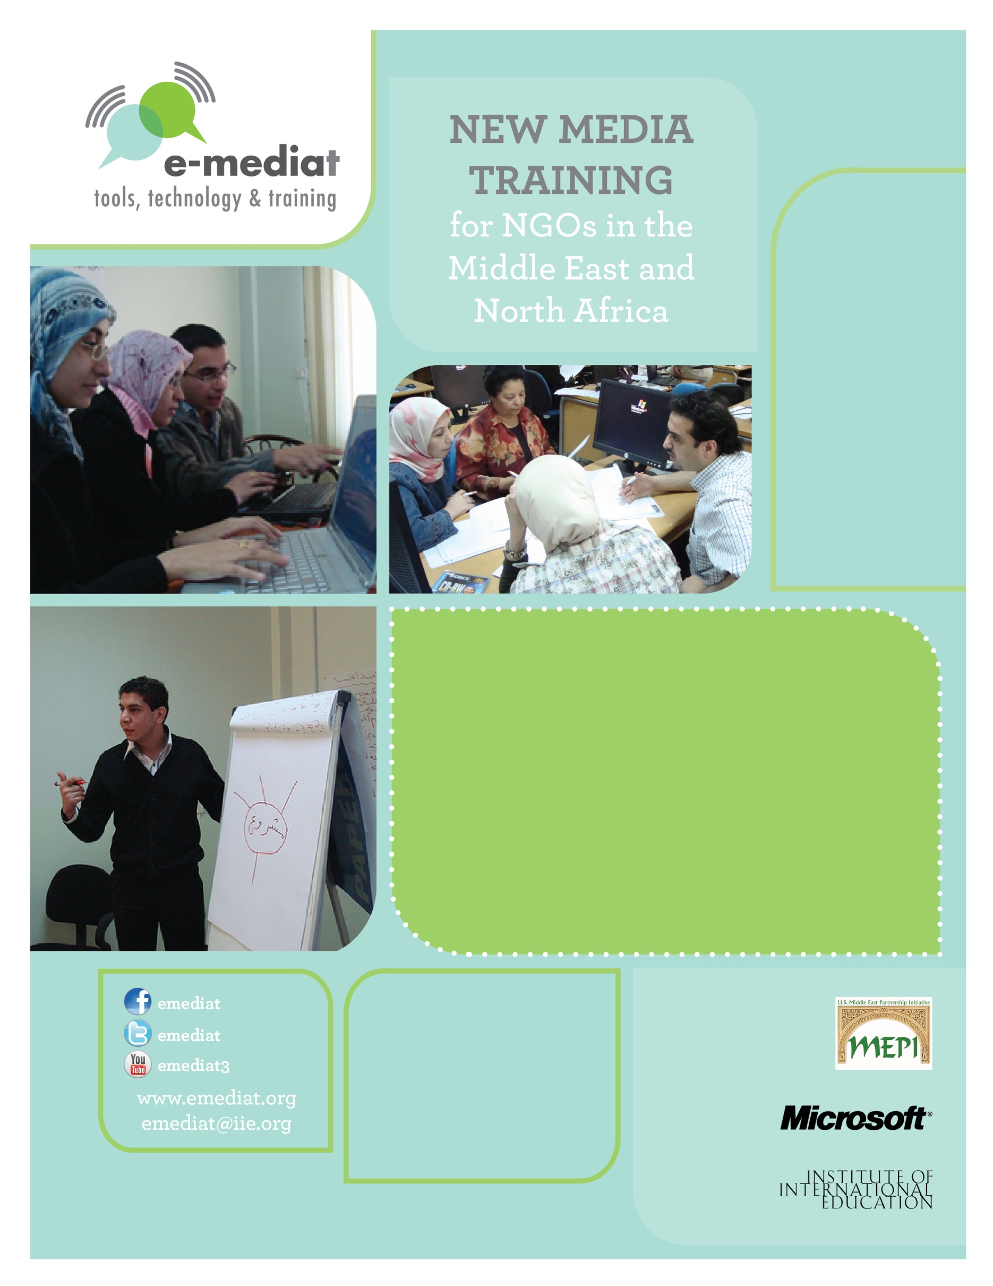
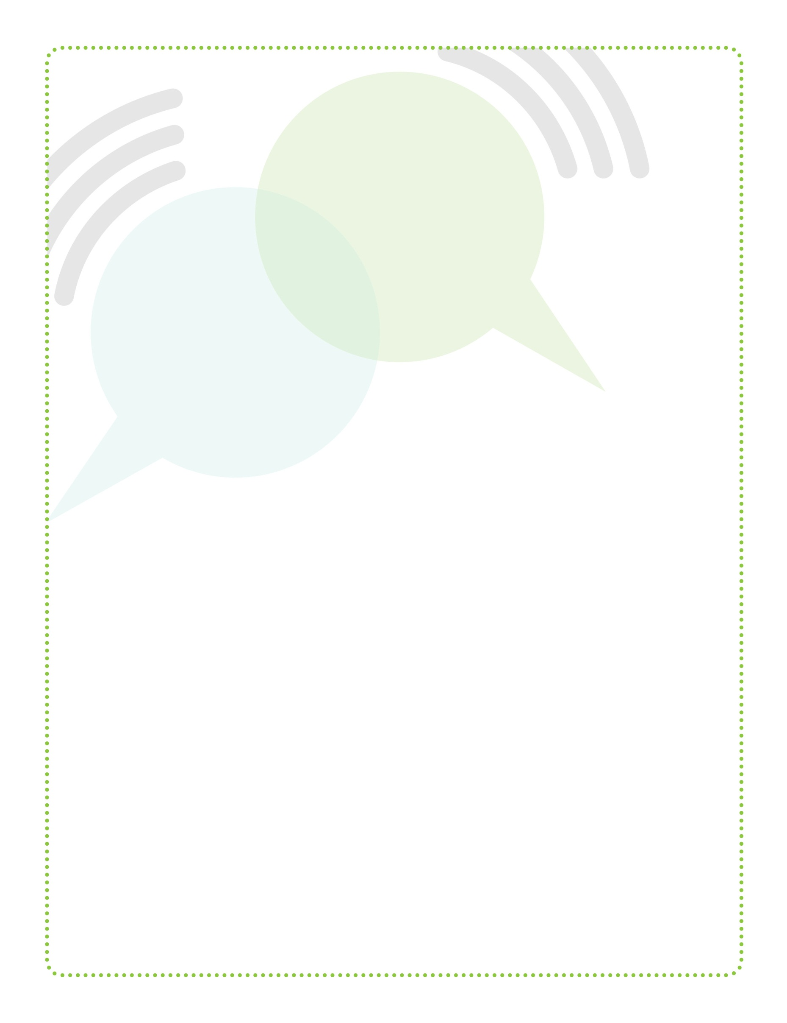

Based on workshops, blog posts, and other material created by Beth Kanter
http://www.bethkanter.org

Trainer’s Guide: Workshop 3
Strategic Social Network Use for NGOs: Facebook & Twitter
E-Mediat: Trainer’s Guide
Workshop 1:
Social Media and Networked NGOs Overview and Strategic Planning
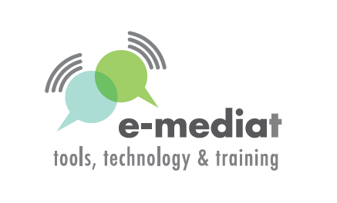

Table of Contents

Overview: E-Mediat Workshops 3
Participant Agenda 5
Day 1: Facebook Strategies for NGOs 5
Day 2: Facebook Engagement & Twitter Strategies for NGOs 6
Detailed Trainer’s Outline & Worksheets 7
Day 1: Facebook Strategies for NGOs 7
Day 2: Facebook Engagement & Twitter Strategies for NGOs 13
Appendix 19
Facebook Content Management Worksheet 20

Overview: E-Mediat Workshops

Workshop | Description
Workshop 1: Social Media & Networked NGOs Overview and Strategic Planning  Day 1: Introduction to social media for civil society and networked NGOs: Principles of  best practices in social media  Day 2: Creating your social media strategy plan  Day 3: Coaching in small groups and one-on-one for NGOs and CSOs: Training on how to use OLC | Day 1 is an overview of social media and examples. Day 2 provides a framework for creating a social media strategy plan. Day 3 is focused on coaching NGOs on their plans in addition to training on the Online Learning Community.
Workshop 2: Listening and Web Presence  Day 1: Listening, security, and privacy  Day 2: Strategic internet presence: Blogs  and/or websites | Day 1 shares techniques and tools for scanning and listening on social media channels, including how to set up and use a simple listening dashboard. Day 2 focuses on how to improve an existing web presence and/or setting up a blog, so they serve as an online home base for the NGO and links to the social media strategy plan.
Workshop 3: Social Networks  Day 1: Using Facebook strategically for NGOs  Day 2: Using Twitter strategically for NGOs | In workshop 3, participants will learn how to use Facebook and/or Twitter and link to their social media strategy plan. If Twitter is not relevant for the participants, the Facebook workshop can be delivered in two days – with hands-on time and shoulder-to-shoulder learning.
Workshop 4: Storytelling with Digital Video  Day 1: How to use simple video tools to support your social media strategy plan (Part I)  Day 2: How to use simple video tools to support your social media strategy plan (Part I) | This hands-on workshop will teach participants how to use storytelling principles to create compelling videos that can be part of a content strategy for a blog, website, or Facebook. Participants will learn how to use simple video tools including FLIP camera, editing software, and YouTube.
Workshop 5: Mobile Strategy  Day 1: An overview of text messaging campaign and the mobile generation  Day 2: Sharing social media strategy plans and learning | Workshop 5 will provide an overview to mobile tools and the mobile generation. As the last workshop, participants will have the opportunity to showcase their social media strategy plans and share what they have learned.

For each Workshop Day, the Trainer’s Guide will include:

1. Participant Agenda: This one page handout is a simple version of the agenda which includes times and session titles. This document can easily be printed and distributed to participants.

2. Trainer’s Agenda/Outline: This section will be a detailed version of the participant agenda and include learning goals, times/titles, and the following detailed information:
- Learning goals
- Content to share
- Timing
- Instructions for the trainer on how to facilitate a discussion or lead an exercise
- Description of materials, such as checklists, PowerPoint decks, or additional resources

3. Workshop Materials:
- PowerPoint Deck: The entire workshop will be in one PowerPoint deck. Additional detailed notes about what to say and points to cover will be included in the notes section of the slide. You should print a notes version of the PowerPoint, which will include talking points and additional instructions for your presentations.
- Templates & Worksheets (If word document, this will follow the trainer’s outline)
- Online Resources (http://emediat.wikispaces.com/Tool+Box) and the Online Learning Community (OLC)

Participant Agenda

Day 1: Facebook Strategies for NGOs

Learning Objectives

- To learn how to use Facebook effectively to support NGO’s social media strategy plan
- To learn how to use Facebook tools and applications to achieve results

Schedule

9:00 – 9:30 Introduction, agenda review and icebreaker

9:30 – 10:00 Why Facebook?

10:00 – 11:00 Facebook features: Page or group?

11:00 – 11:15 Break

11:15 – 12:30 Facebook features: Nuts and bolts

12:30 – 1:30 Lunch
1:30 – 3:00 Hands-on time: Set up Facebook pages and custom landing tabs
3:00 – 3:15 Break
3:15 – 4:30 Facebook best practices: Metrics & benchmarking
4:30 – 5:00 Reflection exercise

Day 2: Facebook Engagement & Twitter Strategies for NGOs

Learning Objectives

- To learn Facebook engagement strategy
- To learn to use Twitter effectively to support NGO’s social media strategy plan
- To learn how to use Twitter best practices to achieve results

Schedule

9:00 – 9:30 Reflections and agenda review

9:30 – 10:30 Facebook engagement strategy

10:30 – 10:45 Break

10:45 – 12:00 Hands-on time: Developing content and engagement plans

12:00 – 1:00 Lunch
1:00 – 2:30 Introduction to Twitter
2:30 – 3:00 Hands-on time: Setting up Twitter profiles

3:00 – 3:15 Break

3:15 – 4:00 Twitter best practices

4:00 – 4:30: Small group work: Developing content and engagement plans

4:30 – 5:00 Reflection and closing

Detailed Trainer’s Outline & Worksheets

Day 1: Facebook Strategies for NGOs

Learning Objectives
- To learn how to use Facebook effectively to support NGO’s social media strategy plan
- To learn how to use Facebook tools and applications to achieve results

9:00-9:30 Introduction, agenda review and icebreaker

- Provide introduction and give an overview of the program
- Introductions
- Review of Workshop 3 agenda

- Exchange ideas through share pairs
  - Ask participants to find partners in the room and answer the following question below. Remember, when you raise your hand, participants should stop interacting.
  - What is one thing you already know or want to learn about Facebook for your NGO?

9:15-9:45 Why Facebook?
- Facebook provides a great platform for organizations to promote their brand, raise money, increase visibility, organize campaigns and have conversations with their communities and networks.
- You can engage more people through Facebook than your websites and blogs.
- There are more than 10,000 Facebook pages for nonprofits. You can browse all nonprofits pages at: http://www.facebook.com/pages/browser.php.
- SMART Intent for your Facebook Page: The participants have a huge advantage because they have already done the hard work of figuring out their communications strategy, audience, and message discipline in Workshop 1. Next step is to identify some SMART social objectives that support these and align to their communications strategy.
- SMART social objectives can come in three types: results, tactics, and capacity.
- The process begins with identifying intent for your social channel. Next, make it specific by adding quantifiable measurements: numbers, percentages, increases/decreases and dates. Some nonprofits find it hard to do this because it requires taking a step back and pausing. Also, there may be a feeling that one is getting “graded” if they don’t make the deadline or hit the target number. SMART objectives can be revised along the way. A couple of generic examples are included in the slides.
- Include a screen capture your E-Mediat Facebook page and discuss your intention and process for making it SMART.

10:00-11:00 Facebook features: Page or Group?

- Advantages of Pages
- Pages and Groups have URLs, but Pages’ URLs are more search-engine friendly and better for branding because they show the name of your Page, i.e. the name of your organization, campaign or issues.
- You can send updates to all Fans, no matter how many you have. With Groups, messages can be sent only to as many as 5,000 members.
- You can reach Fans with updates, whereas Group messages go to the Inbox with all other Facebook notifications
- You can display your logo or visual identity much more prominently on a Page.
- You can add ready-made applications to a page or develop your own. Groups have some applications but you can’t add more.
- Pages can help you create targeted ads using the demographic information of your fans.
- Pages’ connection with Insights (Facebook metric tool which will be discussed later in workshop) allows you to access analytical information about page views, etc so that you can optimize your Page’s effectiveness.
- Pages allow you to restrict access based on age, country and other criteria. You can also publish or unpublish your Page.

- Advantages of Groups
- Groups give you the option of controlling who can or can’t view content or even whether the Group is visible to Facebook members at all.
- Messages to Group members go directly to their Inbox while Pages messages to Fans go to Updates.
- Users are more familiar with Groups and the link to create them is much easier to find. They are also easier to browse

- Converting your Group to Page
- Create Facebook Page
- Note both your Group and Page URLs
- Go to http://www.facebook.com/help/contact_generic.php
- Enter your group URL and your Page URL
- Typically, the conversion will be complete in 4 - 8 hours

- Resources
- http://www.facebook.com/nonprofits
- http://www.thegogglesdonothing.com/archives/2008/01/facebook_groups_vs_pages.shtml

11:00-11:15 Break

11:15-12:30 Facebook features: Nuts & bolts

- Administrators (“Admins”)
These individuals control the membership and content of a group. Admins can edit the group description and settings. They can add more admins to a group. Any admin can also remove or ban current members and other admins.
- After creating a group, you will automatically be listed as an admin and see the "Edit Group" link on the right side of the group page.
- Any group member or admin can make posts in a group using the options at the top of the group. When a post is made, members are notified on Facebook and by email, and they can respond with comments. Members can change their notification settings, but they will always see new posts when they visit the group. Group admins can’t send private messages to all members of a group. The best way to reach all members at once and start a discussion is to make a post in the group.
- Only current admins can add more admins to a group. To add an admin, follow these steps below:
- Add or approve the potential new admin as a member of the group
- On the right side of the group, click "Edit Group”
- Select the Members tab on the left
- Find a member by entering a name in the search box
- Click "Make Admin" under the name of the member you wish to add as admin
- Keep in mind that admins can remove members or admins, add new admins, and edit the group description and settings. You should only add a member as an admin if you already know and trust them.

- Wall
The Facebook wall is a space on each profile page that allows fans/group members to post messages for others to see while displaying the time and date the message was written. Wall posts will show up in the individual’s News Feed.

- Status updates
Facebook has a feature called "status updates" (also referred to simply as "status") which allows users to post messages for all fans/members to read. These updates appear on the Wall. In turn, fans/friends can respond with their own comments and can also press the "Like" button to show that they enjoyed reading it.

- Notifications
These are the more important activities, for example, someone sharing a link on the user's wall or commenting on a post the user previously commented on. Notifications briefly appear for a few seconds in the bottom left as a popup message (if the user is online), and a red counter is updated on the toolbar at the top, thus allowing the user to keep track of all the most recent notifications.

- Events
Facebook events are a way to let fans/members know about upcoming events in their community and to organize social gatherings. Events require an event name, network, host name, event type, start time, location, and a guest list of friends invited. Events can be public or private. Private events cannot be found in searches and are by invitation only.

- Comments
To comment on something:
- Click the "Comment" link under the post or in the white box that says "Write a comment..." if it displays.
- Type your comment.
- Press enter or return to publish it.

- Polls
To poll a group:
- At the top of the group, select "Question".
- Enter your question.
- Add poll options if you wish.
- Click "Ask Question" to share it with the group. Only group members can answer questions or vote on polls that appear in a group.

- Applications
Facebook allows Page/Group Admins to add several apps for sharing photos, linking Flickr and Twitter with Facebook and conducting discussions. To add apps to your page:
- On you ‘Profile’ page click ‘Edit’ in the ‘About’ segment
- You can edit your settings, basic information and profile picture on this page
- ‘Resources’ on the page allow you to send ‘Updates’, link your Facebook to Twitter and use other social plugins
- ‘Apps’ allow you to edit photo and video settings and add Flickr to Facebook.

12:30-1:30 Lunch

1:30-3:00 Hands-On Time: Set up Facebook pages and custom landing tabs

- You can use the following link to get the participants started: http://www.facebook.com/pages/create.php
- Participants will work on setting up their organization’s Facebook Page and creating custom landing tabs.
- Use Pagemodo or any other app that your in-country social media advisor knows how to use well.
- Participants will need to have visuals, logos, or photos available to create the custom tab.
- They should also think through page objectives, value at a glance and a call to action. You may want to create a couple of examples for them ahead of time.
- Resources: Custom tabs can be created with free apps
  - Tunisia team used: http://www.socialshaker.com/
  - The easiest free application to use is: http://www.pagemodo.com/
- Finding and Favoriting Similar pages
- Have participants spend time searching on Facebook.
- They can use social mention and focus it on Facebook to identify and favorite similar pages. In advance of the workshop, you can favorite a lot of pages for your E-Mediat page.

3:00-3:15 Break

3:15-4:30 Facebook best practices: Metrics & benchmarking

Note: Best Practice information and links to resource posts with lots of tips can be found at http://www.bethkanter.org/facebook-smartly/ this post would be good pre-read to send to participants or post on OLC

Measurement
It is important to think about your measurement approach from the beginning. If you’ve set measurable objectives, it will be a matter of collecting data. For the most part, you will be counting how many comments per post or the number of fans. There are two free tools to use: export.ly and the Facebook analytics program called Insights.

Post Feedback
You’ll find this data under “Interactions” in your Page Overview section. It measures the number of “Likes” and comments made on the posts in your News Feed. What to do with this data: Really, you’re looking for the percent increase month-over-month here. If engagement and two-way feedback are among your goals, this is a key statistic to track. What’s more, don’t forget to check out the number of “Likes” and “Comments” throughout the month. Where were your spikes? Did they occur where you wanted them to occur? Did the number of “Likes” and comments on a certain post surprise you?

Monthly Active Users
This metric represents the number of folks who have interacted with (Liked or commented) or viewed (don’t have to be fans) your page or its posts. What to do with this data: First, look at the percentage growth or decline month-over-month–that should give you a good indication of how many people are visiting and interacting with your page compared to the last couple months. Then, look at the number against the “Lifetime Likes” number directly to the left–how does it stack up? Remember, the Monthly Active Users number doesn’t just reflect fans–it also picks up non-fans. So, again, if one of your goals is engagement, this comparison is a good one to grab–and it should be a pretty high ratio.

Page Views
This number represents the total hits to your Facebook page–and it includes fans and non-fans (including those who aren’t logged it to Facebook). You can find it in the Users tab under “Activity.” What to do with this data: Here’s where you can really see what days of the week people are hitting you page and how the spikes correspond with your content. It might make sense to overlay this chart with the days you post. It is also a great way to determine which posts might be encouraging fans to click on your actual page (remember, this isn’t about News Feed views–it’s about actual Facebook page views).

Weekly Metrics Monitoring
Set aside an hour a week in order to learn from your data and reflect on how to improve. Mom’s Rising does something called “Joyful Funeral” because they understand that not everything is going to be successful. By reviewing their metrics, they know what isn’t working and give themselves permission to stop doing it. They also have a “Metrics Monday” where everyone looks at their metrics and comes to a meeting to discuss how to improve. Consider showing the video of their talking about the process: http://www.youtube.com/watch?v=-Vo4M4u5Boc.

4:30-5:00 Reflection exercise

- Do a series of “Share Pairs” where people ask and answer these questions:
- What did you learn today?
- What is still isn’t clear?
- What do you need to move forward?
- What is the most important thing you want to learn tomorrow?

- Then gather in a circle, and have everyone share one word about how they are feeling and why.

Day 2: Facebook Engagement & Twitter Strategies for NGOs

Learning Objectives
- To learn Facebook engagement strategy
- To learn to use Twitter effectively to support NGO’s social media strategy plan
- To learn how to use Twitter best practices to achieve results

9:00-9:30 Reflections and agenda review

- Discuss overnight reflections about Facebook features
- Review agenda for the day: Facebook engagement and Twitter strategies

1) Overnight reflection: As participants arrive at the training, give them a sticky note and ask them to write down the answer to this question: What was your takeaway from yesterday?
- Ask people who are interested in sharing their thoughts with the group to share
- Summarize the key points
- Address any concerns

2) Share pairs: Do a series of share pairs. Ask people to find a partner in the room and share the answers to the question below. Use a bell or “raise your hand” and be quiet technique.
- What is one thing you already know or want to learn about Twitter?

9:30-10:30 Strategic online presence

- Ladder of love: Scaffolding by depth of relationship is a familiar framework for many nonprofits – whether it is donors or activists, everyone has tactics that move people up the “Ladder of Engagement.” This is how it plays out on Facebook: you want to get people from passive attention to “loving” your Facebook page so they will tell other people about your work. The example in the PowerPoint deck is the Minneapolis Museum of Art but please feel free to localize the example.

- Get attention, engage, convert to action, and fall in love: Slides in the PowerPoint showcase different tactics to get people to the next level on the “Ladder of Love.” Localized examples are included.

- How to get attention
- Custom Landing Tab
- Cross Promote Through All Channels
- Text and Print
- Facebook Ads

- Resources
- Custom Landing Pages
http://www.bethkanter.org/facebook-tab/
- 15 Creative Ways To Get Your Facebook Attention
http://www.socialmediaexaminer.com/21-creative-ways-to-increase-your-facebook-fanbase/
- Facebook Ad Case Study
http://www.epolitics.com/2011/06/22/case-study-how-facebook-ads-defeated-a-florida-ballot-initiative/
- Facebook Ads Tips
http://searchengineland.com/15-tips-for-a-successful-facebook-ads-program-80335

- Engagement
- The big mistake that many organizations make is that they don’t pay attention after people click the “like” button. What you want to do is grow an army of “super fans,” or brand ambassadors who will spread your brand and messages across Facebook and to their neighbors. To bring your fans higher up on the ladder of love – to loyalty, leadership, and evangelism – takes consistent engagement and relationship building.
- The secret to success is to engage people by posting good questions.
- “ABC: Always Be Commenting” on your Facebook page. You need to comment quickly, often, and respond to everyone. And, remember, you don’t have to live on Facebook for this to be effective. Another tip is to repeat the proven stuff. Not all your fans will read everything you post and if you are tracking per post interaction, you’ll have a sense of what resonates. Simply repeat it.
- Finally, research shows that posting shorter posts, posts with photos and after hours also works to drive up engagement. It is also important NOT to automate your posting because this gets in the way of interaction because Facebook’s algorithm, Edgerank, tends to hide automated posts from the newsfeed.

- Content to Serve
- Start with an inventory of your content – things that you already have on your website, etc. Then figure out what your outside sources are. You need to have a mix of content that you create and content that you find from other people. This is where the listening skills will be very useful.
- Make sure participants recognize the range of content they can post to their Facebook page. Refer to Facebook Content Management worksheet for details.
- Resources
- http://www.bethkanter.org/facebook-smartly/
- https://spreadsheets.google.com/spreadsheet/ccc?key=0AtsV5h84LWk0dGhDM2FkWDBsRWswODh0WHJxcFFfRXc&authkey=CISFj78K&hl=en_US#gid=0

10:30-10:45 Break

10:45-12:00 Hands-on time: Developing content & engagement plans
Spend this time brainstorming content to post onto Facebook. Once comfortable, participants can begin uploading content. These can be posts from their website/blog, photos from their program, status updates, etc. They should also start to use the “Like” feature. Use this as an opportunity to help participants get their Facebook page really filled up!

The following points will help participants develop their content engagement plans. Review the following points before participants begin developing content.

Create a Voice
One of the most important things a non-profit should do is create a distinct voice. Content needs to have a human voice, not sound like it’s from a marketing department.

Program Your Page
Organizations have to determine what the right amount of posts are, but definitely plan to post regularly so fans/members know what to expect and look forward to coming back for the latest content.

Create Exclusive Content and Programs
This example is rather self-explanatory. Launching new content on Facebook first helps boost engagement on your page, and gives fans a sense of preferential treatment. Your fans have “raised their hand” to say they support your cause, so you should reward them with exclusive content.

Push and Pull
Yes, you’re sending out messages and content to your fans, but your goal is also to “pull” responses back from them. Why? Most importantly because that’s what Facebook is all about, two way dialogue. Also, boosting engagement on your posts helps your non-profit’s EdgeRank, aka how prominently your content shows up in the Facebook Newsfeed. So start asking questions, post polls, and ask for feedback from your fans.

Engage Other Groups and Organizations
Do you have a celebrity or well-known individual on your board of directors? Ask them to engage with your page or post content. Do you partner with other non-profits? Set up a plan to engage on each other’s pages so you can share audiences. The key here is to think about your network and how you can utilize it to help spread the word.

Know Your Supporters
This point ties into number one on the list. Know your supporters and their expectations. Ask for feedback. Have supporters shape your content strategy. The closer you are to your supporters, the better success you will see on Facebook.

12:00-1:00 Lunch

1:00-2:30 Introduction to Twitter

- Icebreaker to introduce Twitter: Show Twitter page on screen and explain it as a social network to keep people connected by using short messages not exceeding 140 characters.
- Demonstrate how it works by typing in this tweet: #emediat Today we learn how to tweet!
- Explain what a hashtag is – a way to create a group conversation about a particular topic.
- Depending whether you’ve introduced participants to Twitter, you may need to do a basic demo using your E-Mediat program account as the example: http://twitter.com/#!/EMediatLB/status/96879291702317056

- Identifying SMART Objectives for Twitter: It is important to have a clear intent and SMART objectives for Twitter. Include your E-Mediat Twitter stream as an example and identify an NGO in your country to use as an example, ideally an organization that is in the E-Mediat project. Twitter objectives can include the following:
- Keep current supporters engaged
- Inspire conversation to support communications goal
- Create buzz around an offline event before, during, and after
- Get new ideas and feedback on programs and services
- Program support to clients
- Drive traffic to website or blog
- Recruit volunteers
- Coordinate meetings with officials and policy leaders
- Identify Influencers like journalists using Twitter and encourage them to use you as a source
- Identify and build relationships with allies & supporters
- Tweet key points about your issue
- Decide who will tweet

- Tips and Tricks to Make Twitter Efficient:
- Share: Share photos and behind the scenes info about developments in your field in your country. Even better, give a glimpse of developing projects and upcoming events. Remember, users come to Twitter to get and share the latest, so give it to them!
- Listen: Regularly monitor the comments about your organization by following individual/institutions associated with your cause and searching conversations by using relevant hashtags. Also, monitor comments about social media in your country or any other relevant information.
- Ask: Ask questions of your followers to glean valuable insights and show that you are listening, especially across field teams. You are also encouraged to “speak” directly to other users by using their twitter handles. For example, you can appreciate program/achievements of other organizations working on similar causes in your country or globally.
- Respond: Respond to compliments and feedback in real time. This helps keep your momentum going!
- Follow: Follow other individual/organizations engaged with your cause in your country/globally.
- Demonstrate wider leadership and know-how. Reference articles and links about the bigger picture as it relates to issues that interest your organization
- Champion your stakeholders. Retweet and reply publicly to great tweets posted by your followers.
- Establish the right voice: Twitter users tend to prefer a direct, genuine, and of course, a likable tone from your organization. Consider having one person designated to tweet in order to develop this “voice.”
- Use hashtags: It is imperative that you use hashtags in order for your tweets to become displayed to a wider audience through searches. Use directly related and other relevant hashtags
- Trends: You can follow Twitter trends in your country or globally and participate in relevant conversations

- Resources
- http://beth.typepad.com/beths_blog/2008/05/my-twitter-on-p.html
- http://bethkanter.wikispaces.com/twitter_primer
- http://manuals.makeuseof.com.s3.amazonaws.com/twitter-guide.pdf

2:30-3:00 Twitter Best Practices

- What You need to know about Twitter
- Mentions: Once you've signed up and chosen a Twitter username, you and others can mention an account in your Tweets by preceding it with the @ symbol
- Message: If you want to privately Tweet to a particular user who's already following you, start your Tweet with DM or D to direct-message them
- Twitter Lists: create lists to organize the people you’re following on Twitter or find new people. Lists offer a way for you to bunch together other users on Twitter into groups so that you can get an overview of what they’re up to. You have the option of keeping these Lists private/public
- TweetDeck: TweetDeck is your personal real-time browser, connecting you with your contacts across Twitter, Facebook, MySpace, LinkedIn, Foursquare and Google Buzz. TweetDeck can be downloaded at http://www.tweetdeck.com/desktop/ and simplifies tweeting directly from the desktop with options to tweets from multiple profiles at the same time. You can use this once you’re comfortable with Twitter.

- Twitter Followers: How to increase your Twitter followers
- Initiate conversations with individuals who are experts in your field
- Tweet relevant valuable non organization centric information
- Network weave – follow groups and organizations involved in related fields
- Promote your twitter account on other properties (web, cards, etc.)
- Use hashtags frequently

- Types of tweets:
  - Retweet your followers
  - Share a link to news relevant to your field with a question
  - Share a link to news relevant to your field with a summary of best point
  - Inspirational quote
  - Something funny
  - Ask questions
  - Introduce people in your network
  - Ask an industry expert a question or retweet
  - Find an influencer in your network and be nice to them

- Resources: The Hashtag for Advocacy Example
http://beth.typepad.com/beths_blog/2009/08/what-are-the-most-effective-ways-nonprofitsfoundations-can-use-twitter-hashtags.html

3:00-3:15 Break

3:15-4:30 Hands on time: Setting up Twitter profiles

Set up your Twitter Profile: Many organizations don’t think through their profile and leave it empty. It is important to have a branded, completely filled out profile. Use this time to help organizations set up their own twitter accounts and profiles.

Basics of Twitter Profile: Your Twitter profile includes the following:
- Location: Under the “Account” tab within the “Settings” area, enter your real name, city and state. This way, people will be more likely to find you.
- One line bio: Write a bio that’s a brief elevator speech so people can get understand your organization and follow you. Also, keep in mind this how the search people also pick up Twitter IDS.
- Short Url: Keep your web-site address short by using bit.ly You can also track who is clicking through to your web site or landing page.
- Logo: In the profile settings, you can upload your logo or photo as JPG, GIF, or PNG. Maximum size: 700k.
- Background Themes: You can use different background themes for your Twitter page - http://www.twitip.com/custom-twitter-backgrounds/
Using Twitter: Spend some time doing the following exercises:
- Search people
- Follow people
- Create lists
- Start re-tweeing
- Start conversations
- Share news links

4:30-5:00 Reflection exercise

- Do a series of “Share Pairs” where people ask and answer these questions:
- What did you learn today?
- What is still isn’t clear?
- What do you need to move forward?
- What is the most important thing you want to learn tomorrow?

- Then gather in a circle, and have everyone share one word about how they are feeling and why.

Appendix

Facebook Content Management Worksheet

1. Existing Content
In order to have a dynamic Facebook page that will attract lots of visitors, you need to have a wide range of content posted regularly. Start with an inventory of your content – things that you already have on your website, blogs, photos, etc. Below, list some examples of content you already have.
Content 1

Content 2

Content 3

Content 4

2. Outside Sources
What content can you re-post from your followers? Are there any events or photos that you can post onto your own site?
Content 1

Content 2

3. Make sure to use a range of content

Here is an example of Facebook content recently posted by the E-Mediat Morocco team:
Date | Facebook Update | Content Type
July 7 | Social Media expert Beth Kanter chats with E-Mediat Morocco | Content from Website/Blog
June 29 | Q. How can I join the group  A. Thank you for your interest to join E-Mediat program in Morocco. We would like to inform you that our program is…  Response: thanx a lot for the info :) ill be glad to learn from you :) | Discussion with Fans/members
June 27 | Group photo from Workshop 1 in Meknes | Photos
June 21 | Awesome video about how technology has benefited NGOs | Related News Content
June 18 | Video of group game at the post lunch training session in Workshop 1 | Video
June 17 | First E-Mediat Morocco training in AGEF Oriental starts today | Event Update

